Day 4 : Defects & Traceability
Learnt
- Defect lifecycle
A defect (bug) is a deviation between expected and actual behavior discovered during test execution.
New → Open → In Progress → Fixed → Retest → Closed
↘
Rejected / Duplicate / Cannot Reproduce
- How TestRail handles traceability (Very Important)
TestRail does not manage requirements or defects natively. It links to Jira for both.
TestRail supports:
- Test Case -> Defect
- Test Run -> Defect
It does not support:
- Requirement -> Test Case (full RTM)
- Bi-Directional Traceability (by default)
This is why we call it Partial RTM.
- Limitations vs Xray
TestRail Limitation | Xray
External System: Operates separately from Jira, requiring integration for a unified workflow, which can feel fragmented. | Native Jira Integration: Turns tests into native Jira issues, offering seamless traceability and a single workflow.
Performance: Can experience slow performance and loading times with large test suites. | Performance: Can experience fast performance and loading times with large test suites.
Reporting: Reporting can be less powerful or cumbersome compared to Xray's native Jira JQL. | Reporting: Leverages Jira's JQL for powerful searching and reporting on test data.
BDD Support: TestRail does not have native Behaviour-Driven Development. | BDD Support: Superior native support for Behaviour-Driven Development (Gherkin syntax highlighting).

Practical
Without Integration -> TestRail shows the Bug ID as text
-> Jira has no idea this test exists
- Linked failed test cases to Jira bugs (or simulated)
Step 1: Create a Jira bug manually
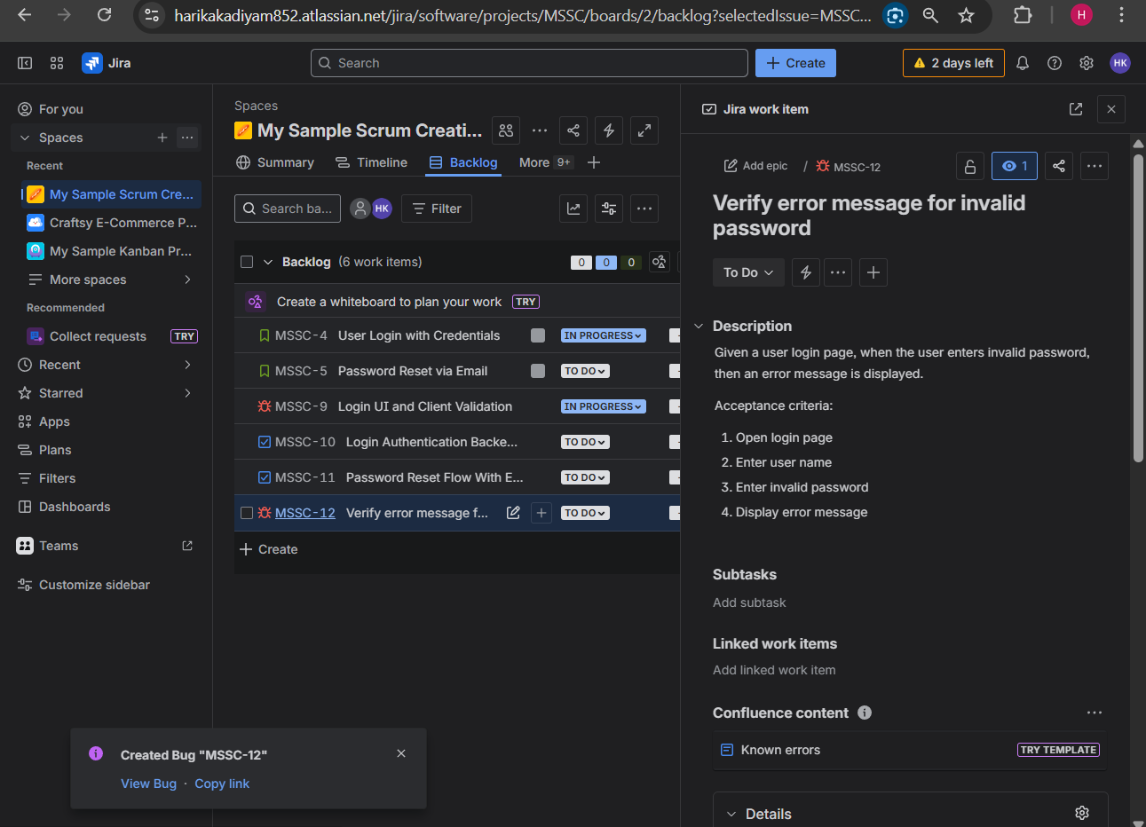
Step 2: Copy Bug ID

Example: https://harikakadiyam852.atlassian.net/browse/MSSC-12
Step 3: Go back to TestRail
Step 4: Click on Test Runs & Results
Step 5: Click on created Test Run
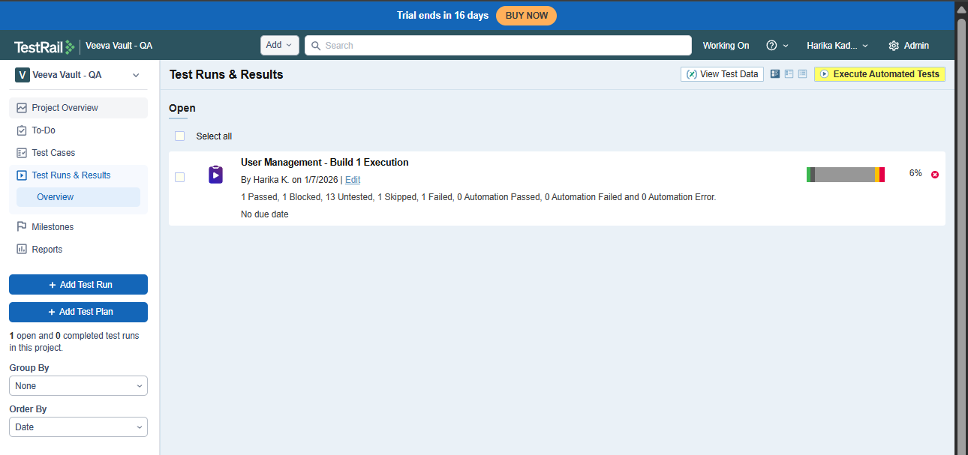
Step 6: Click on the failed test case
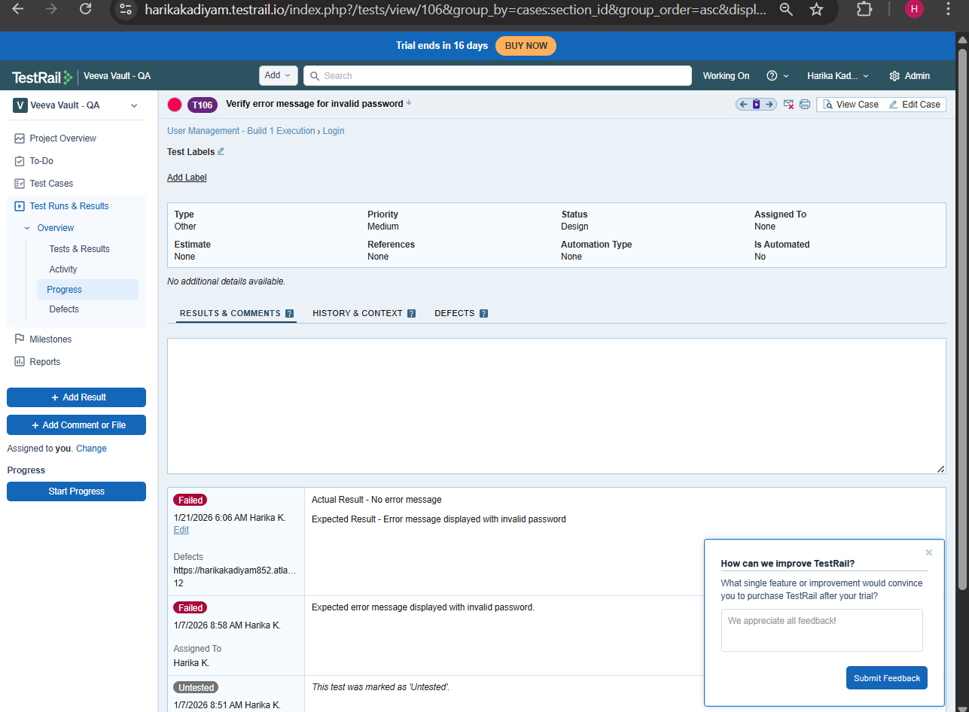
Step 7: Click on Add Result
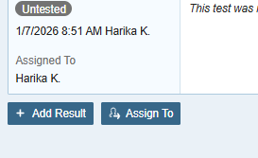
Step 8: Click on Defects field and copy the Bug ID, copied from Jira, then click on Add Result.
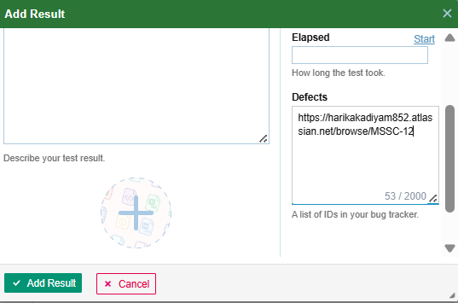
Now Jira defect is linked to the TestRail defect.
- Viewed defect references inside TestRail
Open Test Run
Click the failed test case
Scroll to Defects field

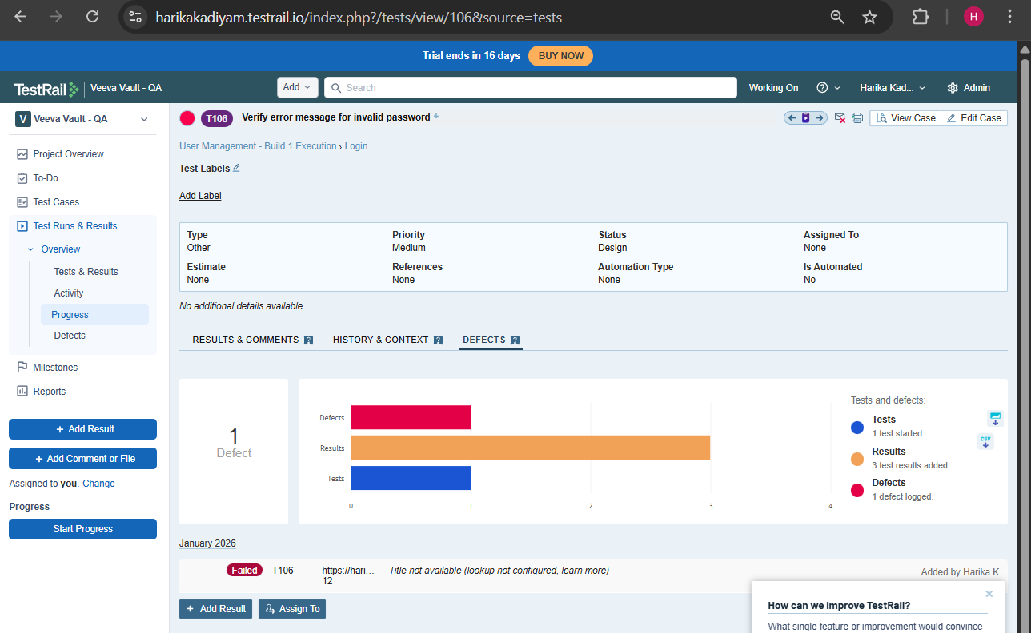
With Integration -> Bug appears in TestRail
->Test Execution link appears in jira
->No copy-paste
->No typo risk
Step1 : Click on Admin
Step2 : Go to Integration
Step3: In integrations tab click on Jira
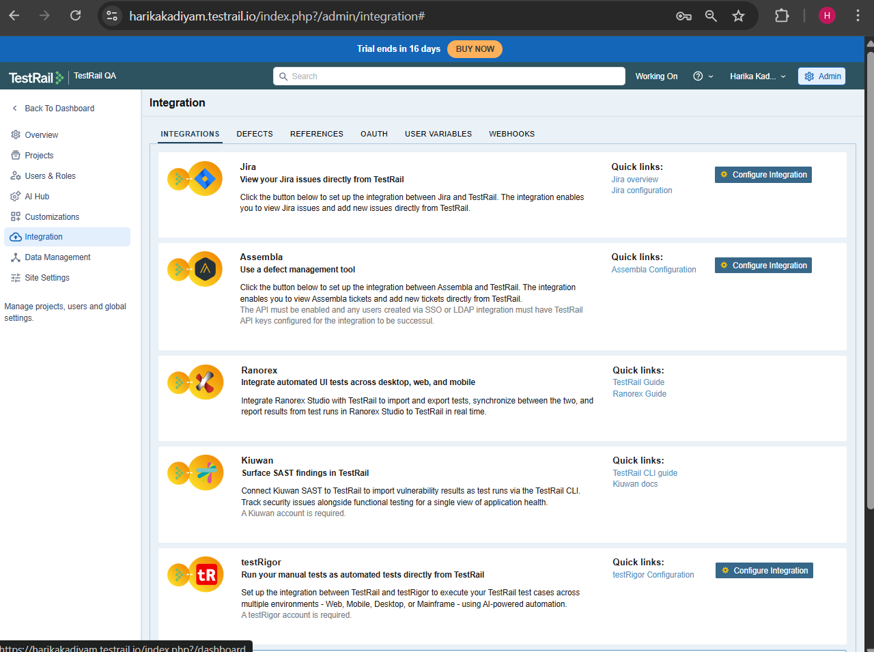
Step4: Click on configure Jira
Step5: Enter Jira Base URL. Example: https://harikakadiyam852.atlassian.net
Step6: Choose Jira Version, commonly jira cloud.
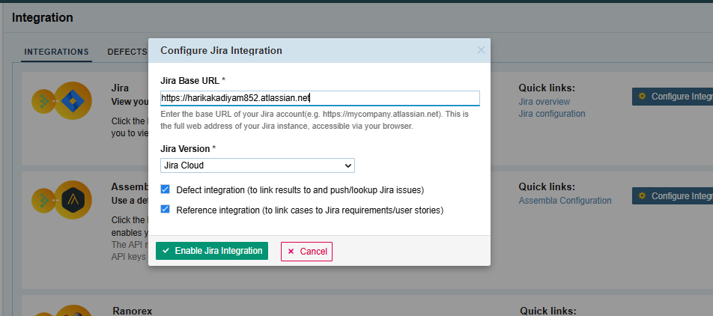
Then you are redirected to the below page for authentication.
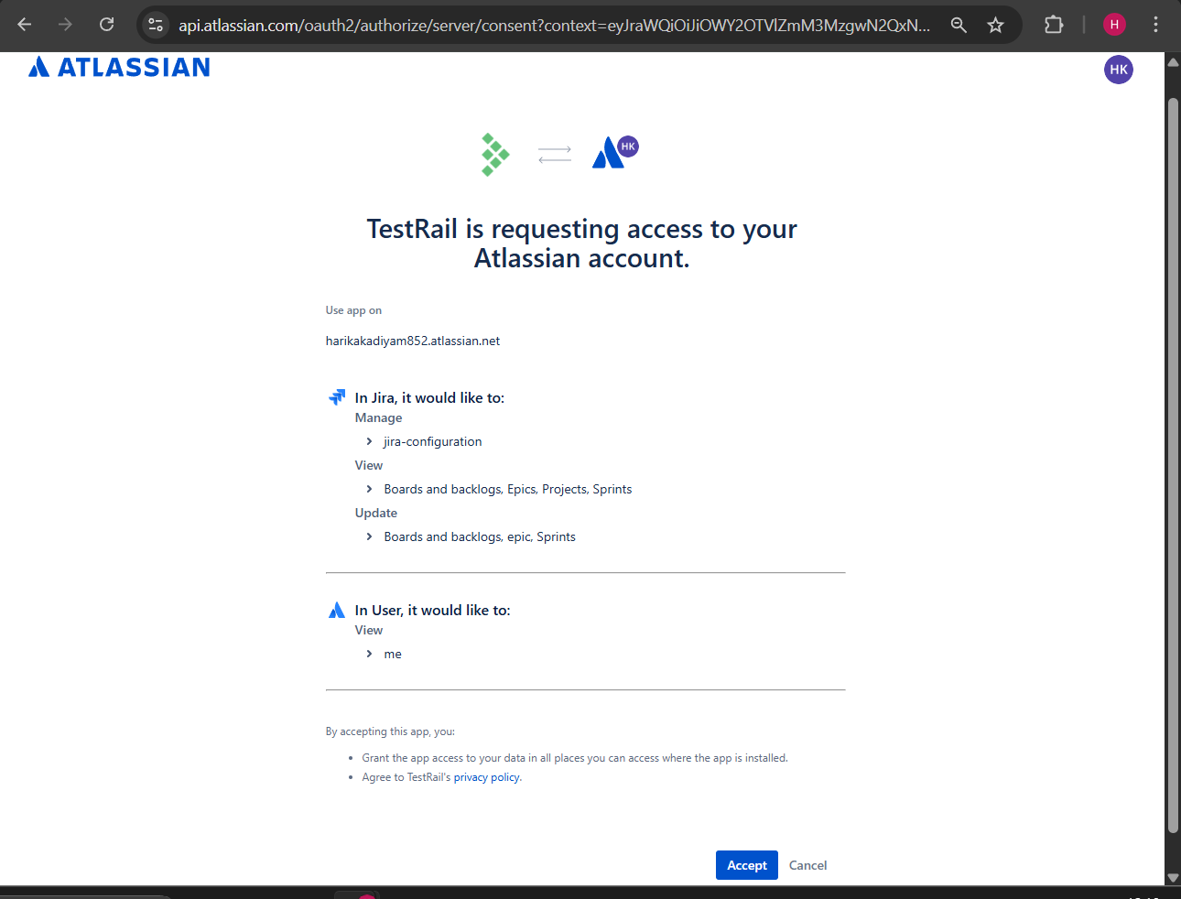
Integration successful.
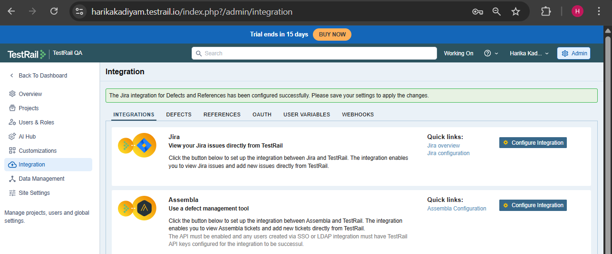
Click on save settings to save the configuration.
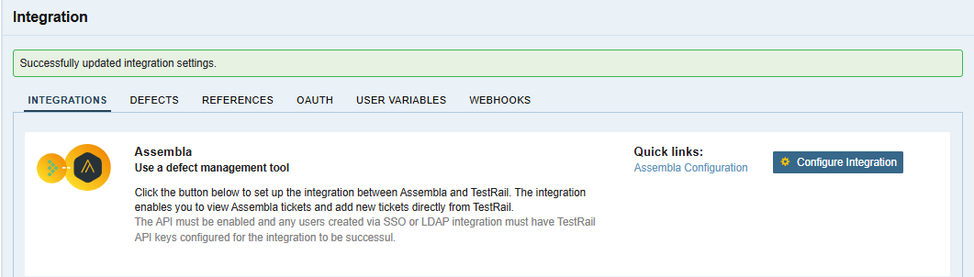
- Understood:
- Partial RTM in TestRail
  - What TestRail can trace:
Test Case → Test Run → Defect
  - What it cannot trace:
Requirement → Test Case → Defect

